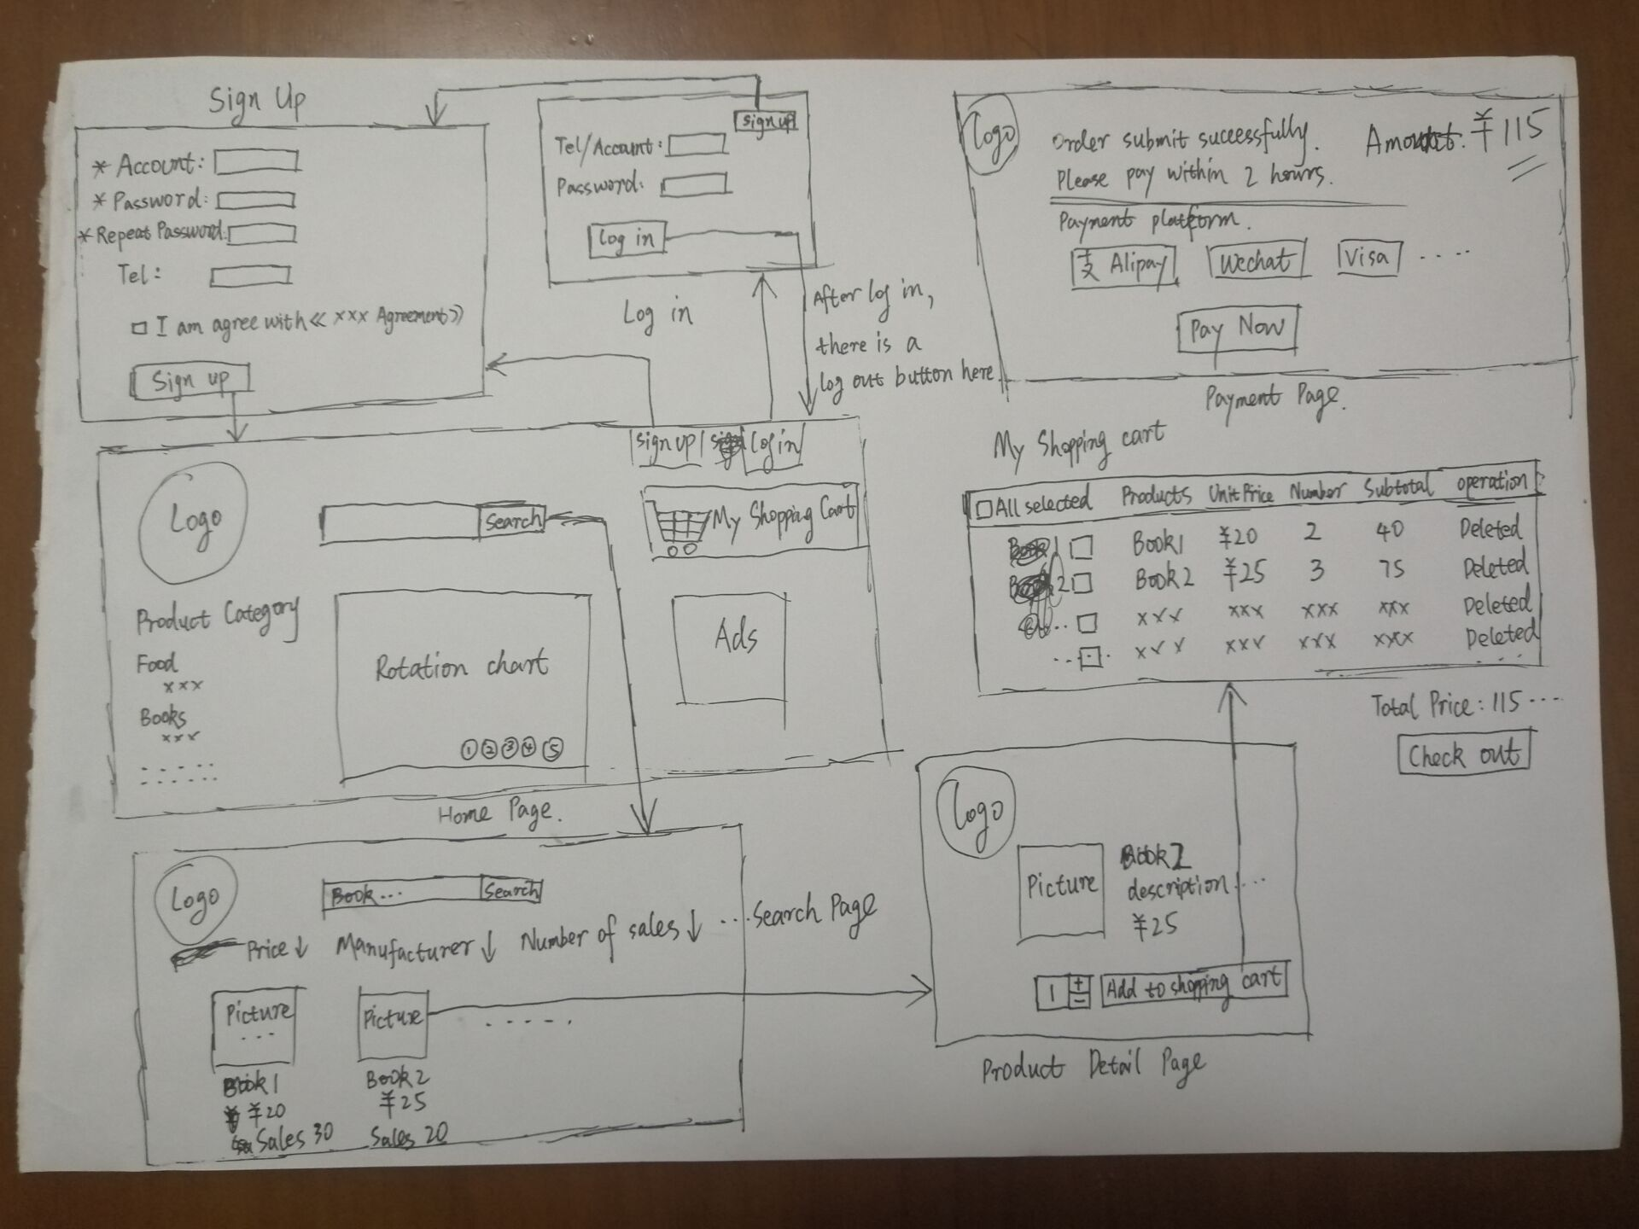

Github link: <https://github.com/yourests/Full-Stack-Developer-eMart>